



**BTEC IT**

**Pre-transition work 2023-24**

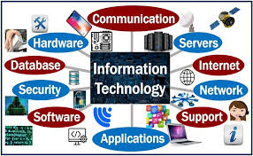

**Course Overview / Introduction**

* Welcome to the **BTEC Level 3 National Extended Certificate in Information Technology**
* The Pearson BTEC Level 3 National Extended Certificate in​Information Technology is equivalent in size to 1 A level
* Over the next two years you will complete four units - two are internally assessed (coursework) and two are externally assessed (exams)
* The qualification gains UCAS points and is recognised by higher education providers
* You will develop employability skills such as cognitive and problem-solving, team working and appropriate research skills

**Units you will study**

Unit 1 – Information Technology Systems – External, 120GLH, Exam

Unit 2 – Creating Systems to Manage Information – External, 90GLH, Exam

Unit 3 – Social Media in Business – Internal, 90 GLH

Unit 6 – Website Development - Internal, 60 GLH



**CLICK HERE**

[BTEC Nationals | Information Technology (2016) | Pearson qualifications](https://qualifications.pearson.com/en/qualifications/btec-nationals/information-technology-2016.html)ons/btec-nationals/information-technology-2016.html

**For**

**further**

**course details**

The BTEC course you are about to embark on will enable you to discover different ways of studying and learning. For example:

**Teaching and Learning Styles**

* Group/Pair work Discussions
* Class debates
* Student presentations
* Research Projects
* Media – film / music / interactive websites
* Role play
* Replication of studies
* Independent study/reading
* Extended writing
* Quizzes and games

**Organisation is the Key to Good Study Skills**

**How to be organised:**

* Number and date all your notes and handouts to keep them in order.
* Use a folder and file dividers to separate each unit for coursework.
* Take responsibility for catching up if you miss a lesson due to illness or trip. Find the resources that you missed and photocopy a friend’s written notes.
* Check the relevant section in the textbooks and make extra concise notes if it improves your understanding.
* If you do not feel confident about a area, consult your teacher. Never be afraid to ask for help if you do not understand.
* Always come prepared to class, bringing course file, writing equipment, class notes from previous lessons, diaries etc.
* If at any point you feel overwhelmed by the work – call for help – wave – do not drown!



CLICK

**Task 1**

Here are some key terms that you need to be familiar with when you start this course.

Fill in the table below, writing your definition in the box on the right-hand side. This is considered AO1, knowledge.

|  |  |
| --- | --- |
| **Term** | **Definition** |
| Accessibility |  |
| Cloud computing |  |
| Operating system |  |
| User interface |  |
| Application software |  |
| File type |  |
| Storage device |  |
| Utility software |  |
| Legislation |  |
| VPN |  |
| Digital device |  |
| Output device |  |
| Input device |  |
| Hard disk drives |  |
| Solid state drives |  |
| SD cards |  |
| Magnetic tape |  |



CLICK HERE

[What Is Amazon Go and How Does it Work? (makeuseof.com)](https://www.makeuseof.com/tag/amazon-go-work/)

**Task 2**

Amazon Go is a cashier-less store wired up with cameras and sensors that track a shopper’s every move. Artificial intelligence is used to recognise specific shopper behaviours. The amount of data gathered is mindboggling.

1. Identify the input devices used in store

|  |
| --- |
|  |

1. Identify the hardware devices used in store
2. Explain what data is collected in store
3. Explain what Amazon hopes to gain by collecting all this data

**Task 3**

**Answering these questions will help you with your first unit; Digital Devices in Systems**

1. Define what a digital device is
2. Identify at least 5 digital devices along with their uses/functions
3. A business will make use of make use of digital video cameras and the internet for their security system. Explain two advantages of using such a system
4. If you were travelling to school by train, what type of digital device would be appropriate to use? Explain two reasons why the device you choose would be appropriate
5. JP Lucy is a chain of small department stores, with five branches. State two different data capture and collection systems that might be used in the department store
6. Reflect; what would your life be like without the digital devices you use every day? How would you arrange to meet up with friends? How would you do research for a college project?

**Task 4**

Go to: [https://map.what3words.com](https://map.what3words.com/)

1. Search for the location *input.caring.brain*. What is at this location?
2. Search for your home, school or college. What is the three-word location of your front door or the main entrance?
3. What are the advantages of the what3words system over postcodes?

# **Hacker gang Clop publishes victim names on dark web**

**The names and company profiles of dozens of victims of a global mass hack have been published by a cyber crime gang holding their stolen data to ransom.**

On Wednesday, the hacker group Clop began posting names of firms to its website on the darknet. Twenty six organisations including banks and universities have been added to try to pressure victims into paying.US federal bodies have also been targeted. The US Cybersecurity and Infrastructure Security Agency told CNN it "is providing support to several federal agencies that have experienced intrusions affecting their MOVEit applications".

It is not known which agencies are affected or what data stolen, but cyber authorities say they do not expect it to have significant impact. The mass hack is likely to have affected hundreds of organisations around the world with around 50 so far confirmed either by the firms themselves or by the hackers.

On the hacker's so called 'leak site' there are companies from the US, Germany, Belgium, Switzerland and Canada. Oil giant Shell was posted on Wednesday and has since confirmed it is a victim. The BBC is choosing not to name the other firms.

Ransomware gangs like Clop use their leak sites to "name and shame" victims into paying by posting company profiles. It is a well-trodden and often profitable process. "Once Clop names companies to its data leak site, the group will start its rounds of negotiations with affected organisations, demanding ransom payments in order to avoid their data being breached, said Chris Morgan, senior cyber threat intelligence analyst at ReliaQuest. Mr Morgan says the hackers will hope that the victims make contact and set a deadline of how long they have before their data is made public. Clop has been known to demand ransoms of hundreds of thousands, sometimes millions of dollars but police forces around the world discourage victims from paying as it fuels these criminal gangs. The MOVEit hack was first disclosed on 31 May when US company Progress Software said hackers had found a way to break into its MOVEit Transfer tool.

MOVEit is software designed to move sensitive files securely and is popular around the world with most of its customers in the US. Progress Software said it alerted its customers as soon as the hack was discovered and quickly released a downloadable security update.

But the criminals were already able to use their access to get into the databases of potentially hundreds of other companies. Payroll services provider Zellis, which is based in the UK, was a MOVEit user which was subsequently breached.

Zellis has confirmed that eight UK organisations have had data stolen as a result, including home addresses, national insurance numbers and, in some cases, bank details. Not all firms have had the same data exposed. Zellis customers which have been breached include the BBC, British Airways, Aer Lingus and Boots

**Task 5**

1. Rate how confident you feel about your understanding of the following words.

**Red – Amber – Green**

|  |  |
| --- | --- |
| **Key Word** | **Rate your understanding** |
| Cybersecurity |  |
| Ransomware |  |
| Hacking |  |
| Cybercrime |  |
| Sensitive |  |
| Infrastructure |  |
| Profile |  |
| Breached |  |

1. Can you use two of the words above in sentences to show you understand their meaning? Write a sentence in the box below

|  |
| --- |
|  |

1. In your own words provide an overview of the article

**CAREER PATHWAYS IN INFORMATION TECHNOLOGY**

<https://nationalcareers.service.gov.uk/job-categories/computing-technology-andd-digital>



**Careers in IT**

**3D printing technician**

3D printing technicians make different products, such as medical implants, car parts, aircraft parts or fashion accessories.

**App developer**

App designer, mobile app developer, application developer

App developers design and build mobile applications for PCs, mobile phones and tablets

<https://nationalcareers.service.gov.uk/job-categories/computing->technology-and-digital

**The National Careers Service**

What does the National Careers Service do? They provide high quality, free and impartial information advice and guidance to help you make decisions on learning training and work

https://nationalcareers.service.gov.uk/

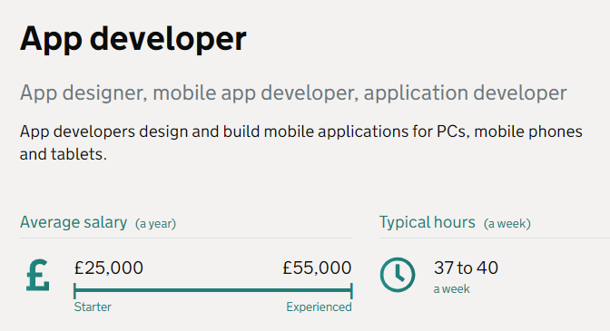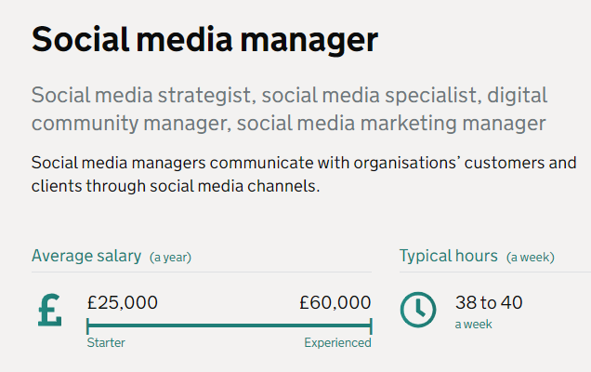

**Find an apprenticeship**

https://www.gov.uk/become-apprentice

nationalhelpdesk@findapprenticeship.service.gov.uk

Telephone: 0800 015 0400

**How apprenticeships work**

Apprenticeships combine practical training in a job with study.

As an apprentice you’ll:

* be an employee earning a wage and getting holiday pay
* work alongside experienced staff
* gain job-specific skills
* get time for training and study related to your role (at least 20% of your normal working hours)
* Apprenticeships take 1 to 5 years to complete depending on their level.